EXP NO 11: Online Supermarket System
Aim:
To create a cloud-based Online Supermarket System using Zoho Creator.
Steps:
- Create a new application.
- Create an Online Supermarket form.
- Add fields: Customer Name, Address, Phone Number, Email, Item Name, Quantity, Price, Item Classification, and Total Amount.
- Create reports to view customer orders.
- Enter sample records and verify the application.
IMPLEMENTATION:
product = Products[ID == input.Product];

if(input.Quantity <= 0)
{
alert "Enter valid quantity";
}
else if(input.Quantity > product.Stock)
{
alert "Insufficient stock";
}
else
{
input.Total_Amount = product.Price * input.Quantity;
product.Stock = product.Stock - input.Quantity;
input.Status = "Confirmed";

alert "Order placed successfully!";
}OUTPUT:
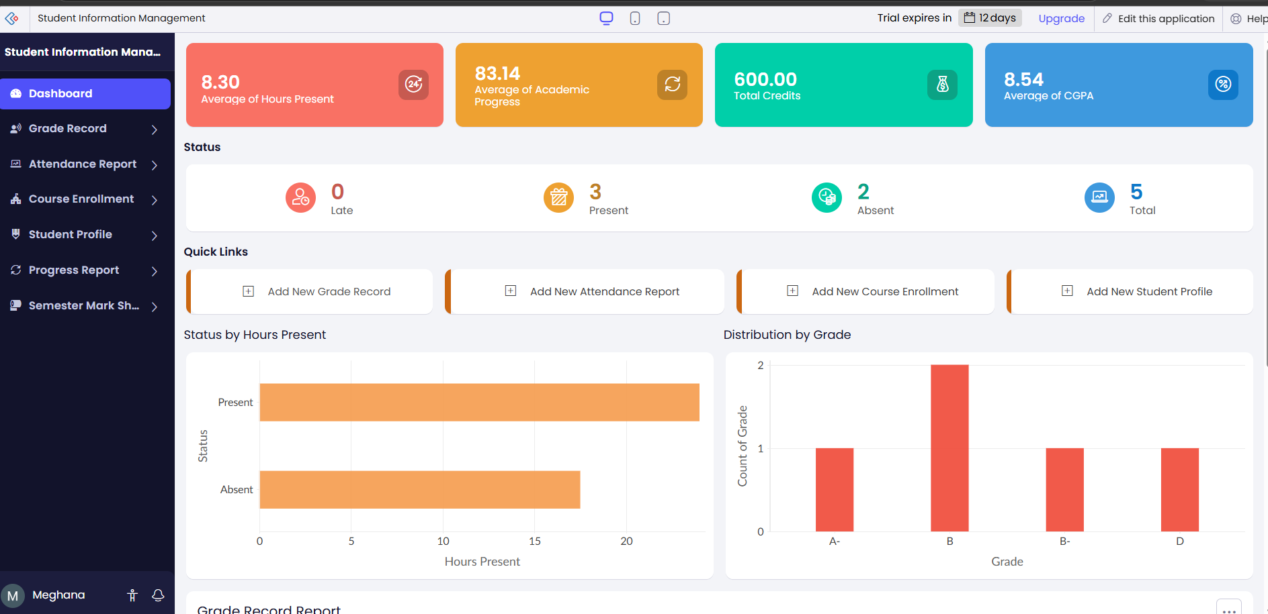
RESULT:
Product price × quantity is calculated, stock is checked and automatically reduced, and the order status becomes Confirmed.

